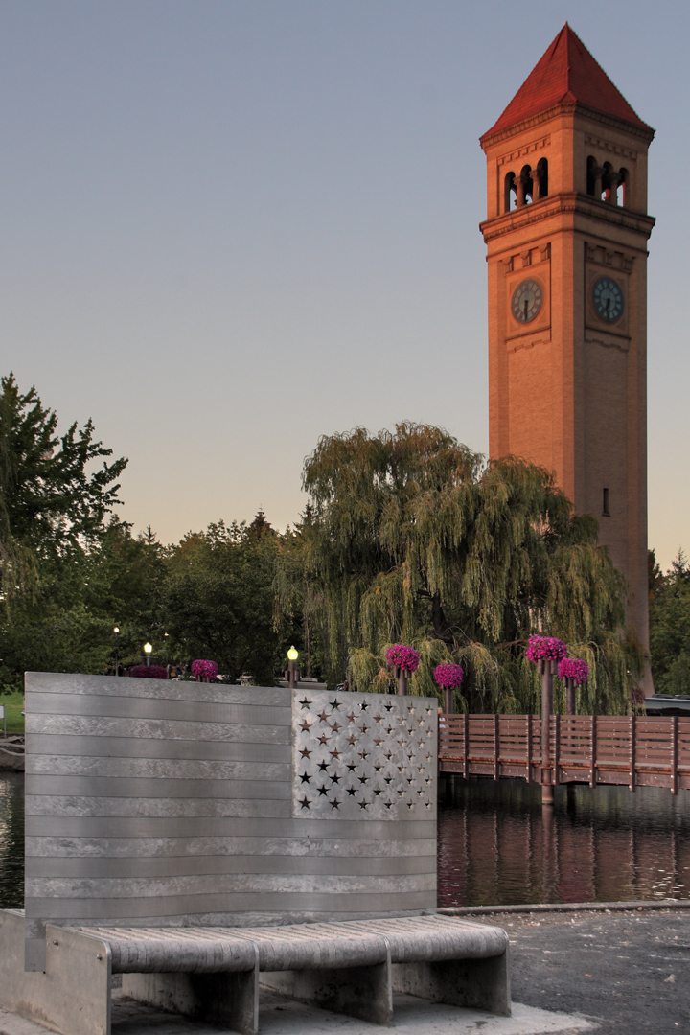
10 THINGS YOU MAY WANT TO
KNOW ABOUT SPOKANE

- Spokane City/County
Population: 230,160 / 549,690 Downtown Spokane elevation:
1,890 feet
- Places to visit within 20 minutes
Wineries - 20
Breweries - 31
Coffee shops - 319
Including 13 local roasters!
Parks in Spokane - 87

- Average number of sunny days:
260

- Number of Golf courses within 75
miles: 40

6. Minutes from airport to downtown: 10
7. Average summer temperature: 85 degrees
8. Number of Ski areas within 75 miles: 5
9. Average commute time: 30
Minutes
10. Number of lakes within 50
miles: 76

INTERNAL MEDICINE RESIDENCY SPOKANE
BENEFITS 2023 - 2024 YEAR

General Benefits
Internal Medicine Residency Spokane offers the following items.

Salaries for current year

Training Year Amount

R-1 $64,235
R-2 $66,647
R-3 $69,448
GIM Teaching Fellow $102,126

Meals
We provide a meal stipend for residents while on duty. This benefit averages $3000/year.

Parking
Residents are provided free parking at all training sites

Additional
Educational resources provided
- ACP Membership during residency ($130/yr)
- Medical Knowledge Self-Assessment Program provided to seniors ($410)
- University of Washington’s Health Sciences library, with hundreds of online databases and ejournals, including Up To Date, Dynamed, JAMA, etc.
- One-time $1000 educational stipend is provided for books/apps

Laboratory Coats
One monogrammed lab coats are provided during the R1 year and an additional one in your R3 year. You are welcome to purchase more, if desired ($60/coat)

Certifications
Providence pays for your medical license and DEA

Exams Paid
- Step III USMLE or COMLEX if taken intern year ($915/$910)
- ABIM Exam if taken year you complete training ($1430)

Time off
- 3 half days off per year for “wellness” to attend to personal needs
- 200 Provider Time [PTA] hours
    - 160 hours [4 weeks] of vacation 40 hours [5 days] for illness – up to 40 hrs can be carried over to the following year

Medical and other Insurance Plans​
- 3 medical plans – two with a health savings account​
  - There is a health incentive plan that will deposit $700 in your savings ​
account for the employee or $1400 for employee and dependent. If you choose the HMO plan there is a premium credit.​
- 3 dental plans ​
- A vision plan​
- Short term disability paid at 100% for 8 weeks​
- Long term disability at 66 2/3% for weeks 10-26 and 60% after 180 days​
- Paid parental leave for both mom and dad

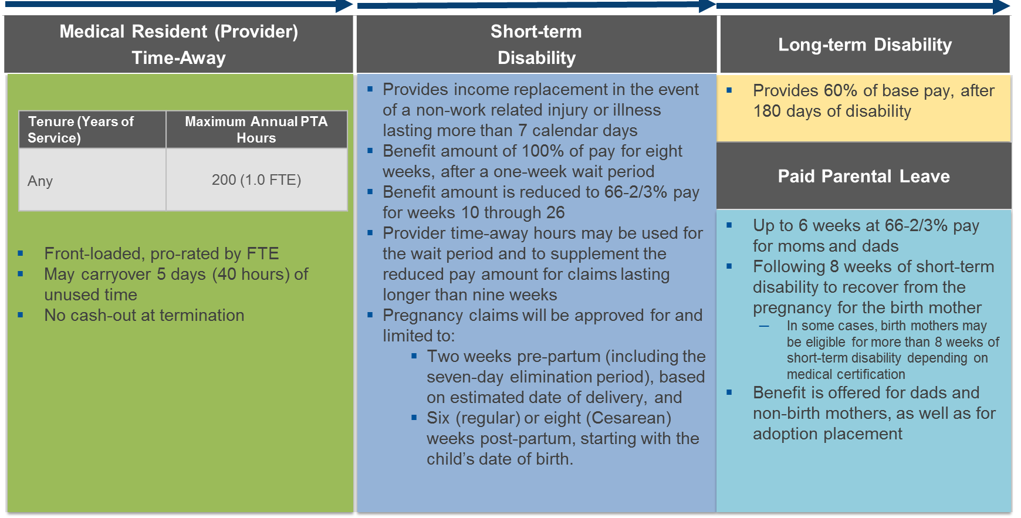

2024-2025​ | #1​ | #2​ | #3​ | #4​ | #5​ | #6​ | #7​
Orientation 6/17-6/21​ | 6/24-7/21​ | 7/22-8/18​ | 8/19-9/15​ | 9/16-10/13​ | 10/14-11/10​ | 11/11-12/8​ | 12/9-1/5​

#8​ | #9​ | #10​ | #11​ | #12​ | #13​ | Last R1 vacation 6/23-6/29 Start R2 year 6/30/25​
1/6-2/2​ | 2/3-3/2​ | 3/3-3/30​ | 3/31-4/27​ | 4/28-5/25​ | 5/26-6/22​ | Last R1 vacation 6/23-6/29 Start R2 year 6/30/25​

INTERNAL MEDICINE RESIDENCY SPOKANE
2023-2024 Resident Curriculum

We have 13 four-week rotations each year.
R1s start one week before seniors to provide contintuity of patient care on the services.

R-1 Rotations

How many? | Name of Rotation | # of Days/Wk
4 | General House staff | 6 days/wk
1 | Inpatient Cardiology | 5 days/wk
1 | Medical ICU | 6 day/wk
1 | ICU nights | 5 nights/wk
1 | Inpatient GI | 5 days/wk
1 | Emergency Medicine | 20 shifts/rotation
1 | Night Shift | 5 nights/wk
2 | Ambulatory (continuity clinic) | 5 days/wk
1 | Elective (such as OP Pulm,Nephrology) | 5 days/wk
On-going | Continuity Clinic (not on ICU, house staff or ICU/house staff nights) | ½ day/week

House staff rotations
- Half of your house staff rotations will be 2 wks on/off
- House staff is “drip, not bolus” NOT long call/short call
- All house staff is attended by residency faculty
- Intern day off is on the weekend

Call duty is on Friday and/or Saturday nights
- Weekend call coverage for house staff and ICU services is 5-6 nights/year, while on electives
- If on call both Friday and Saturday nights, you will come in at noon on Friday, attend conference and then go to your regular assignment until 5:30, when your call shift begins
- You’ll have less than five 24-hour shifts/year on Fridays; 2 of which are on ICU
- You’ll have 14 days of emergent call. These are days you may be need to cover for a colleague unable to come in, due to illness or emergency, you carry your pager 24/7
R-2 Rotations
How many? | Name of Rotation | # of Days/Wk
1-1/2 | General House staff* | 6 days/wk
1 | Hospitalist Consult Service | 5 days/wk
1 | Medical ICU | 6 day/wk
1 | Outpatient Cardiology | 5 days/wk
1 | Night Shift | 5 nights/wk
1 | Ambulatory (continuity clinic)* | 5 days/wk
1 | Endocrinology | 5 days/wk
1 | Infectious Disease | 5 days/wk
1 | Inpatient Neurology | 5 days/wk
½ | Inpatient psychiatry consultation service | 5 days/wk
½ | Systems of Medicine | 5 days/wk
½ | Geriatrics (Community clinics) | 5 days/wk
1 | Elective (Derm, Ethics, GI, GIM, Palliative Care, POCUS, Radiology) | 5 days/wk
On-going | Continuity Clinic (not on ICU, house staff or night float) | 1 day/wk

R-3 Rotations
How many? | Name of Rotation | # of Days/Wk
2 | General House staff* | 6 days/wk
1 | Inpatient Pulm | 6 days/wk
1 | Medical ICU | 6 day/wk
1 | Inpatient Cardiology | 5 days/wk
1 | Hospitalist Service – shifts model hospitalist schedule | 2 7/day shifts
1/2 | Night Shift | 5 nights/wk
1 | Ambulatory (continuity clinic)* | 5 days/wk
1 | Nephrology | 5 days/wk
1 | Hematology/Oncology | 5 days/wk
1 | Outpatient Pulmonology | 5 days/wk
1 | Outpatient Rheumatology | 5 days/wk
1-1/2 | Elective (CICU, Derm, Ethics, GI, GIM, Heart Failure, Life Flight, Palliative Care, POCUS, Radiology) | 5 days/wk
On going | Continuity Clinic (not on ICU, house staff or ICU/house staff nights) | 1 day/wk

*General House staff rotations are split into 2 wk increments and paired with Ambulatory or Outpatient electives to preserve continuity of care.

Call
- R2s have 8 nights of call/R3s have 5 nights of call to cover the house staff and/or ICU patient services.
- R2s have approximately 3 weeks of emergent call; R3s have 2 weeks of emergent call.

HOLIDAYS - We recognize the following 6 holidays:
New Year’s day, Memorial day, 4th of July, Labor day, Thanksgiving day and Christmas day.

You’ll be assigned to work 3-4 of the above holidays total over 3 years of residency on an IMRS service [house staff night/day or ICU night/day]. However, you may be required to work a holiday on other services [not controlled by IMRS] as part of that rotation for patient continuity. Those days are not counted in the holiday calculations above.

INTERNAL MEDICINE RESIDENCY SPOKANE

Fellowship and Graduate Information

Below are graduates of Internal Medicine Spokane from the last three years and their post-graduate positions.

We work to ensure that residents are happy with their career choices following graduation from our program. Training prepares the resident to be a primary care practitioner, a hospitalist, or a subspecialist. 75% of our graduates remain or return to practice in the Pacific Northwest.

Name | Post-Graduate Position

2023
Seth Dotson | IMR Teaching Fellow Providence/STHC, Spokane, WA
Sam Duddempudi | Hospice, Austin, TX
Jenna Hennessey (Speltz) | Hospitalist Providence, Spokane, WA
Cecily Hummer | Hospitalist MultiCare, Spokane, WA
Jeff Kilcup | Infectious Disease Fellow Wake Forest, Winston-Salem, NC
Sarah Knight | IMR Teaching Fellow Providence/STHC, Spokane, WA
Cayce Martin | Hospitalist Providence, Spokane, WA
Ivan Martinez | Critical Care Fellow, Univ of Alabama, Birmingham, AL
Aditya Nathan | Sports Medicine Fellow Providence/STHC, Spokane, WA
Jenna Williamson | Hospitalist Skagit Valley, Mt. Vernon, WA

2022
Caroline Catalano | Hospitalist Wenatchee, WA
Matthew Coons | Hospitalist Providence Spokane, WA
Timothy Hayes | Hospitalist Providence Spokane, WA
Vanessa Hoytfox | Fellow Pulm Critical Care, FL
Kaitlund Johnson | Hospitalist Providence Spokane, WA
Arianna Kamaliazad | Hospitalist Providence Spokane, WA
Tyler Reinking | Rural Medicine, Ketchum, ID
Elizabeth Savage | Infectious Disease Fellow Univ of Kansas, Lawrence, KS
Bryan Takisaki | Hospitalist Providence Spokane, WA
Brittney Ward | Fellow Pulm Critical Care, FL
2021
Aaron Canfield | Hospitalist Providence Spokane, WA
Tiffany Fernandez-Neel | Rural Hospitalist Colville, WA
Jose Gomez Bautista | Hospitalist Tri Cities, WA
Travis Hughes | Sports Medicine Providence Spokane, WA
Christine Janke | Hospitalist, Kauai, HI
Patrick Kunkel | Outpatient, Providence Spokane, WA
Jeremy Stevens | Outpatient, Providence Spokane, WA
Michael Stewart | IMR Faculty Providence Spokane, WA
Scott Tetz | Hospitalist Providence Spokane, WA
Tyson Vandehey | Hospitalist Providence Spokane, WA

R1 CLASS

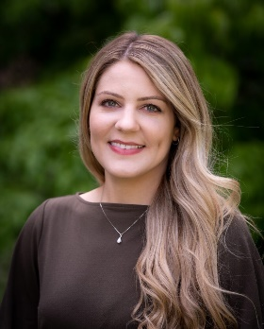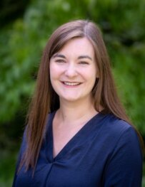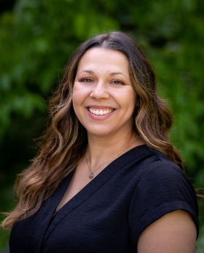
Andrea Cronrath, MD
Univ of Washington
Andrea.cronrath@providence.org

Taylor Eymann, MD
Univ of Washington
Taylor.eymann@providence.org

Tawny Gonzalez, MD
Univ of Washington
Tawny.gonzalez-yetter@providence.org

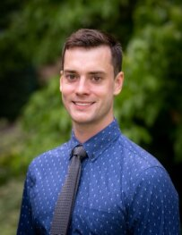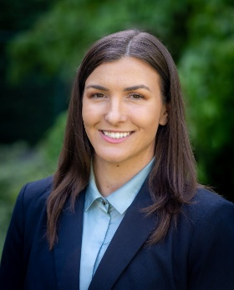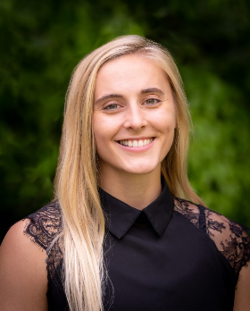
Aaron Kahn, DO
Pacific NW Univ
Aaron.kahn@providence.org

Naomi Leon-Guerrero, DO
Pacific NW Univ
Naomi.leon-guerrero@providence.org

Hanna Meek, DO
A.T. Still Univ
Hanna.meek@providence.org

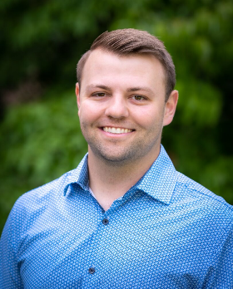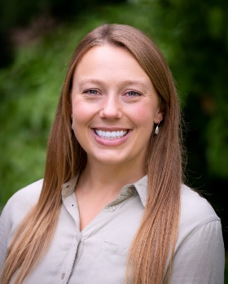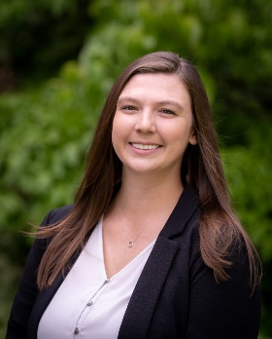
Connor O’Neill, DO
Pacific NW Univ
Connor.o’neill@providence.org

Jessica Wahlgren, MD
Univ of Minnesota
Jessica.wahlgren@providence.org

Connor O’Neill, DO
Pacific NW Univ

Paxton Smith, MD
Univ of Washington
Paxton.t.smith@providence.org

Paxton Smith, MD
Univ of Washington

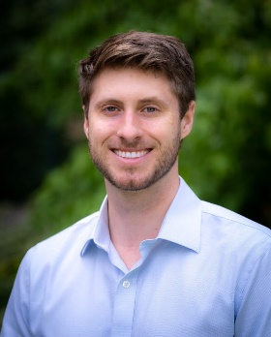
Connor O’Neill, DO
Pacific NW Univ

Michael Watling, MD
Univ of Washington
Michael.watling@providence.org

R2 CLASS
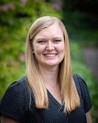
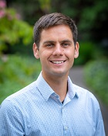
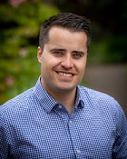

Travis Fisher, MD
Loma Linda Univ
Travis.fisher@providence.org
Carsten Kirby, DO
Pacific NW Univ
Carsten.kirby@providence.org
Laura DeWald, DO
Pacific NW Univ
Laura.dewald@providence.org

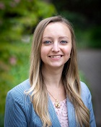
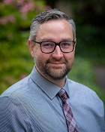
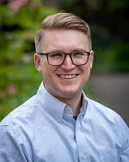

Ester Peters, DO
AZ Midwestern Univ
Ester.peters@providence.org
Chad Ruger, MD
Univ of Washington
Ryan.ruger@providence.org
Ken Scott, DO
Idaho Osteopathic
Kenneth.scott2@providence.org

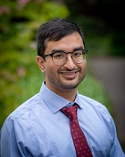
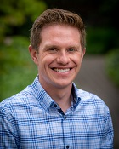
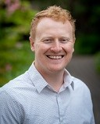

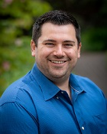
Rakin Solaiman, MD
Univ of Minnesota
Rakin.solaiman@providence.org
Victor Warr, DO
Rocky Vista Univ
victor.warr@providence.org
Jacob Straus, DO
Pacific NW Univ
Jacob.straus@providence.org

Kyle Wyer, DO
Rocky Vista Univ
Kyle.wyer@providence.org
R3 CLASS

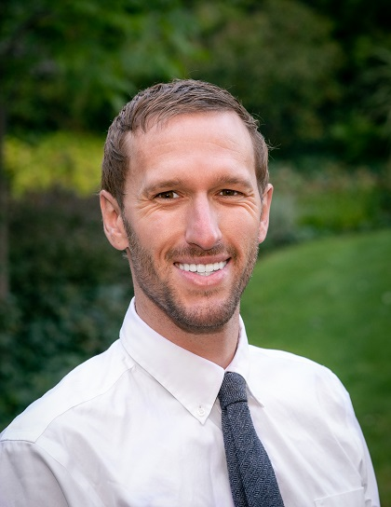
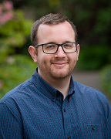
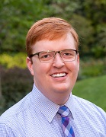

Alex Crist, DO
Midwestern Osteopathic
Alex.crist@providence.org

Kyle Davies, DO
Pacific NW Univ
Kyle.davies@providence.org

Sam Eglin, MD
Univ of Washington
samuel.eglin@providence.org

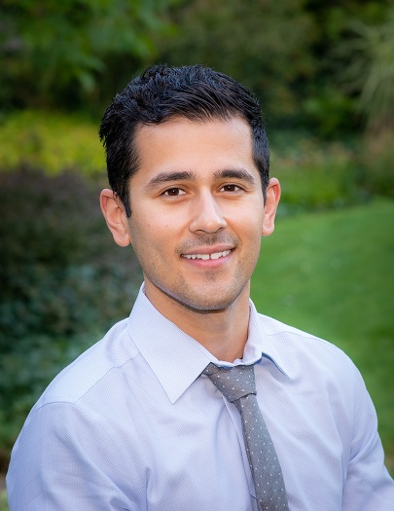
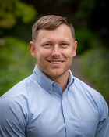
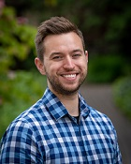

Sam Josephsen, MD
Washington State Univ
samuel.josephsen@providence.org

David Pash, DO
Pacific NW Univ
David.pash@providence.org

Cody Howdeshell, MD
Ross University
Cody.howdeshell@providence.org

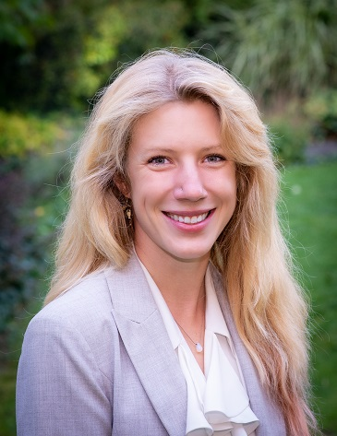
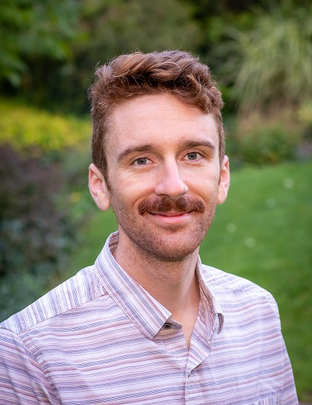
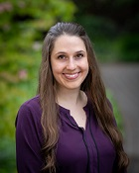

David Waples, DO
Kansas City Univ
david.waples@providence.org

Alix Silha, DO
Pacific NW Univ
Alixandra.silha@providence.org

Sharon Uhder, MD
Univ of Washington
sharon.uhder@providence.org

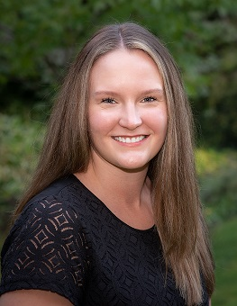

Amanda Yelle, MD
Washington State Univ
amanda.yelle@providence.org

.
2023-2024 Internal Medicine Residency Faculty

Judy Benson, MD
Clinical Professor, University of Washington
School of Medicine
Medical School: University of Nebraska, 1983
Residency: Internal Medicine Residency Spokane
Certified: Internal Medicine

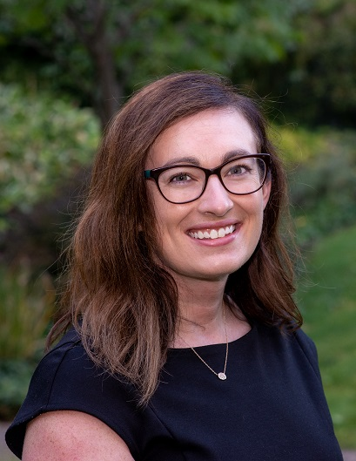
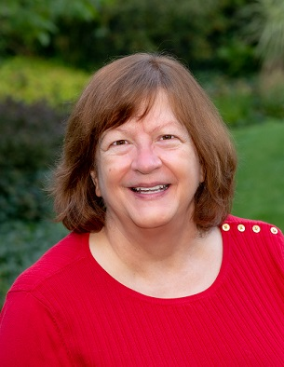
Caitlin Allen, MD
Primary Care Track Director
Medical School: Univ. of Washington, 2013
Residency: University of Wisconsin-Madison
Certified: Internal Medicine

Certified: Internal Medicine

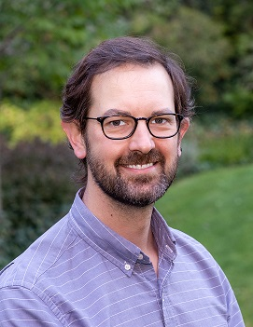

Amy Eddy, MD, Program Director
Clinical Assistant Professor, University of Washington School of Medicine, and Elson S. Floyd College of Medicine
Clinical Faculty, Pacific NW Univ of Health Sciences
Medical School: Univ. of Washington 2010
Residency: Internal Medicine Residency Spokane
Certified: Internal Medicine

Michael Kerkering, MD, Clinic Director
Medical School: Univ. of Washington 1994
Residency: Internal Medicine Residency Spokane
Certified: Internal Medicine
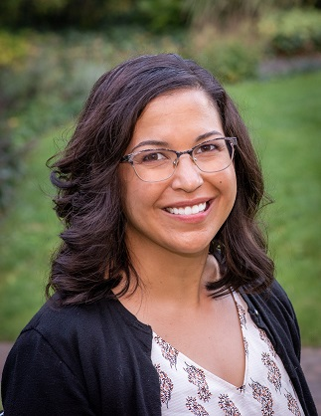
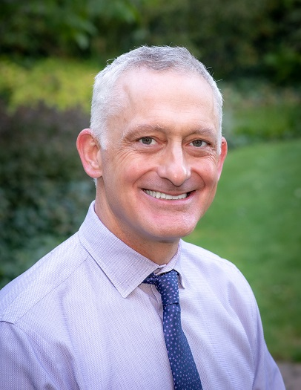

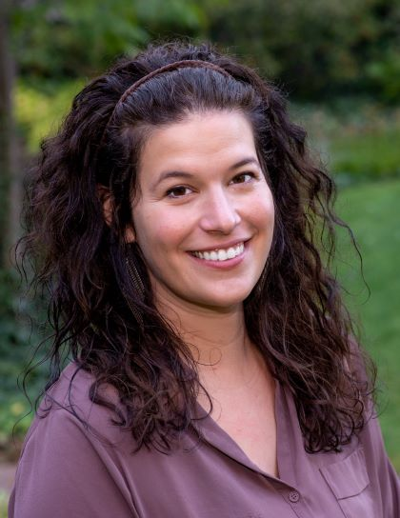
Ian May, MD, Associate Program Director
Clinical Instructor, University of Washington School of Medicine
Medical School: University of Washington, 2013
Residency/Fellowship: Internal Medicine Residency Spokane
Certified: Internal Medicine

Jessica Lundgren, DO
Medical School: Des Moines University 2015
Residency: Internal Medicine Residency Spokane
Certified: Internal Medicine

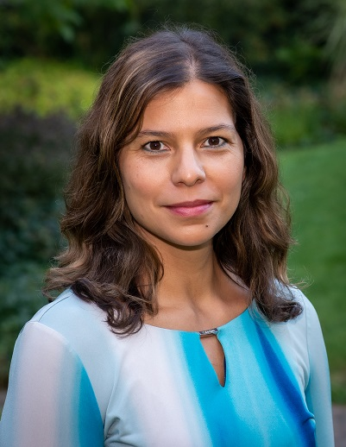
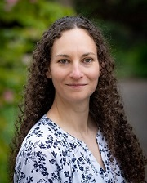
Carmen McDermott, MD,
Faculty Hospitalist, Sacred Heart Medical Center
Clinical Instructor, University of Washington School of Medicine, and Elson S. Floyd College of Medicine
Medical School: University of Washington 2004
Residency: University of Washington Certified: Internal Medicine

Sarah Newton, MD
Medical School: Univ. of Texas Health Science Center 2015
Residency/Fellowship: Internal Medicine Residency Spokane
Certified: Internal Medicine

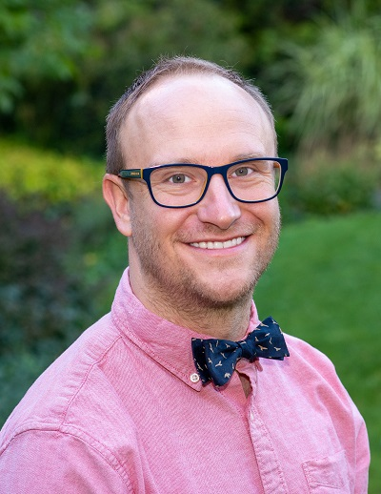
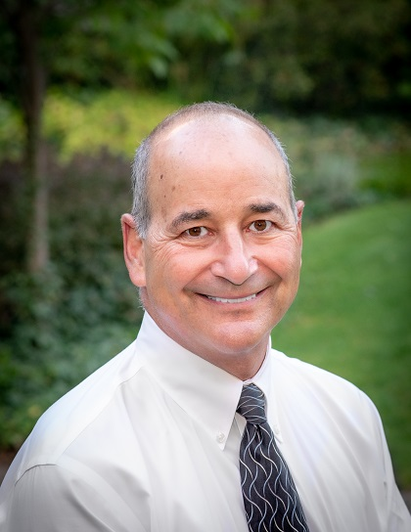
Darryl Potyk, MD
Clinical Professor, University of Washington
School of Medicine
Medical School: University of Southern California, 1986
Residency and Fellowship: Harbor-UCLA
Certified: Internal Medicine, Geriatrics

Michael Stewart, MD
WWAMI Site Clerkship Coordinator
Clinical Instructor, University of Washington
School of Medicine
Medical School: Western University, 2018
Residency/Fellowship: Internal Medicine Residency Spokane
Certified: Internal Medicine


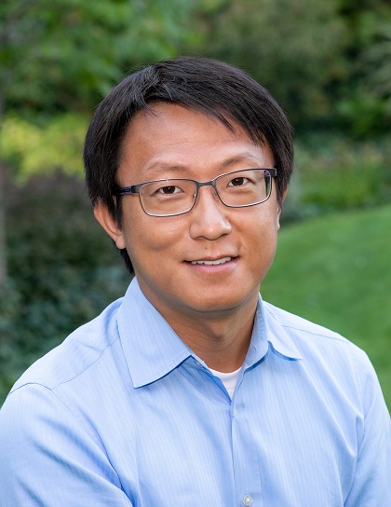
Judy Swanson, MD
Transitional Year, Program Director
Clinical Associate Professor, University of Washington
School of Medicine
Medical School: University of Washington, 1988
Residency: Internal Medicine Residency Spokane
Certified: Internal Medicine

Kang Zhang, MD, Associate Program Director
Clinical Instructor, University of Washington
School of Medicine
Medical School: American University of the Caribbean 2011
Residency/Fellowship: Internal Medicine Residency Spokane
Certified: Internal Medicine

2023-2024 GIM TEACHING FELLOWS

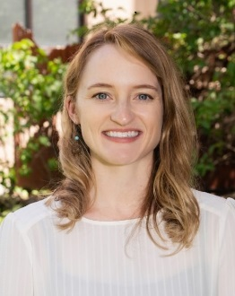
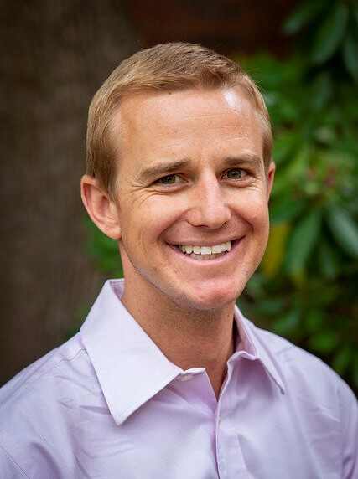
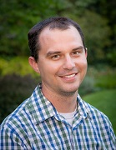

Seth Dotson, MD
Univ of Washington

Sarah Knight, DO
Pacific NW Univ

Providence Internal Medicine Residency Spokane

Director
Amy Eddy, M.D.
amy.eddy@providence.org

Associate Directors
Michael Kerkering, MD  michael.kerkering@providence.org  Clinic Director | Ian May, MD  ian.mayprovidence.org | Kang Zhang, MD  kang.zhang@providence.org
Core Faculty
Caitlin Allen, MD  Primary Care Track Director  caitlin.allen@providence.org | Judy Benson, MD judy.benson@providence.org
Jessica Lundgren, DO  jessica.lundgren@providence.org | Carmen McDermott, MD  carmen.mcdermott@providence.org
Sarah Newton, MD  Sarah.newton@providence.org | Darryl Potyk, MD  darryl.potyk2@providence.org
Michael Stewart, DO  WWAMI Site Clerkship Coordinator  Michael.stewart2@providence.org | Judy Swanson, MD  Transitional Year Program Director  judy.swanson@providence.org

GIM Fellows
Seth Dotson, MD  Seth.dotson@providence.org | Sarah Knight, DO  Sarah.knight@providence.org

Program Staff
Teri Yaeger  Program Coordinator  teri.yaeger@providence.org | Holly LiVecche  Program Assistant  holly.livecche@providence.org
Shauna Hamilton Program Assistant shauna.hamilton@providence.org | Liz Patterson, R.N. Patient Care Coordinator  Elizabeth.patterson@providence.org

Internal Medicine Residency Spokane
What is special about the IMRS Clinic in the Spokane Teaching Health Clinic?

- Clinic is where you will learn to be the kind of physician you would want for your parents, your family, yourself. This is your continuity clinic; you will get to know your own patients and follow them over time. Your relationship with your clinic patients develops and deepens in the three years during which you provide their care.

- Each resident has their own medical assistant who helps with communication, refills etc. They know most of the patients well and can ‘prepare’ you for what to expect with your patient. We also have excellent interdisciplinary support in-house from social work, pharmacy, and psychology services.

- Our clinic patients are diverse: Lots of great patients with interesting medical problems – from the hospital and community with a broad spectrum of common medical problems (DM, HTN, chronic renal failure, chronic hepatitis, HIV, Hep C, rheumatologic disorders etc.) as well as many very challenging and more unusual problems.

- In addition to learning by the experience, we do lots of teaching in clinic with:
- Morning teaching sessions every day:
  - Case-based Yale Office-Based Medicine Curriculum
  - Topics presented by residents & faculty
  - Coding for billing [so that over 3 years you will gradually learn how to do it]
  - Specialty presentations: Endocrinology, Sports Medicine, Dermatology
- Small group motivational interviewing training is provided for all R1s that includes submitting recordings for detailed feedback from faculty with advanced MI training.
- Noon Conferences at Sacred Heart are video conferenced into the STHC Classroom.
- Direct Observation to help with exam, communication etc [video camera in exam rooms]
- Precepting every patient encounter with faculty- who use this to review medical knowledge, approaches to problems, etc.

- Specialty clinics: During clinic rotations residents can work one-on-one with specialists in Endocrinology, Dermatology, Psychiatry and Sports Medicine in the clinic. Residents also go off-site to spend time with Podiatry.
- HIV and PreP: We also have one of the largest integrated primary care HIV clinics in the state where senior residents have the unique opportunity to learn to manage HIV/AIDS as a chronic disease within your primary care panel, along with the support from multiple certified HIV specialist faculty. Additionally, all residents are trained and equipped to provide PreP (pre-exposure prophylaxis) care to eligible patients.

- Primary care mentors: Much of our faculty have primary care panels embedded within the clinic! This means residents are able to learn first-hand from role models who are doing patient care alongside them. We also have a core of amazing outpatient focused faculty who are developing a primary care track where residents will be able to opt-in to a pathway with additional training and professional development opportunities.

- STHC is a unique setting with collaborative teaching, learning and patient care, with more associated health specialties preparing to join us!

Michael Kerkering, MD
Ambulatory Clinic Director
Michael.kerkering@providence.org

